Library Website
Prepared by: Alhassan Alhadidi

This document provides an overview of the Library Website, including its purpose, functionality design. The website enables users to read books securely and simplicity while offering features such as read books tracking, a user-friendly interface. It is designed with a responsive layout, matching a consistent color theme, and supports integration with secure browsing systems.

Purpose and Goals:
Purpose: To provide a seamless and user-friendly way for individuals to read a book.
Goals:
- Simplify the reading book process.
- Increase accessibility for books readers.
- Create a sustainable and scalable website for browsing books.

Features Overview:
- User-Friendly Interfaces:
Easy to use for all users

- Responsive calculation system: After every reading it calculates the amount of the reading and
increases it and increase number of readers.

●Technical Stack:
Frontend:
HTML, CSS: for
design and layout. JavaScript: for interactivity.

Backend:
php: for server-side logic.

Database:
phpMyAdmin: to store users information for login and readers info.

Website walk through:
01 login page

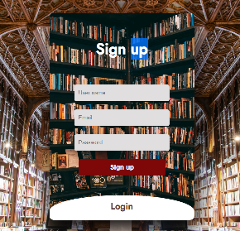

02 Dashboard page
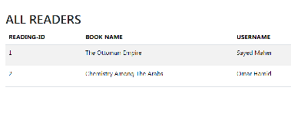

03 Admin Dashboard page

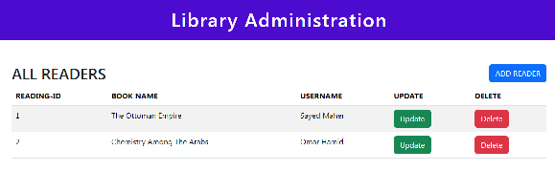

- Books page

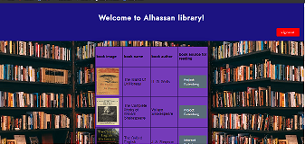

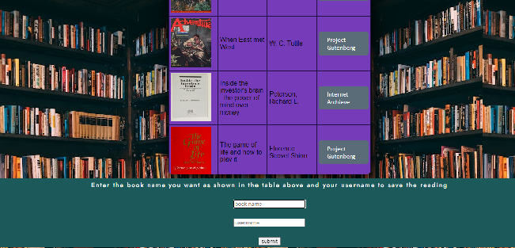

Live Demo:
- Open the website and enter your account information then press login button. If you don’t have account press the sign up button.
- When you login/sign up the library page, it will appears
- Choose the book you want to read. If you want to save your reading, then you should enter your username and book name.

